Dockerized Healthcare Python Flask Service

Manufacturing Operational Insights Report

  - Course Name: DeveOps Foundation

Institution Name: Medicaps University – Datagami Skill Based Course

Student Name(s) & Enrolment Number(s):
Sr no | Student Name | Enrolment Number
1. | PRAKHAR JAIN | EN24CA5030122
2. | AAYUSH | EN22IT301004
3. | DANISH SHAIKH | EN22IT301032
4. | KOMOLIKA VYAS | EN24CA5030083
5. | KASHISH BILALA | EN24CA5030079

Group Name: Group 04D12
Project Number: DO-42
Industry Mentor Name: Vaibhav
University Mentor Name: Akshay Saxena
Academic Year:2025-2026

Table of Contents
Page No.
1. Introduction 3
2. Problem Statement & Objectives 4-9
2.1 Problem Statement 4-5
2.2 Project Objectives 6-7
2.3 Scope of the Project 8-9
3. Proposed Solution 10-18
3.1 Key features 10-12
3.2 Overall Architecture / Workflow 13-16
3.3 Tools & Technologies Used 17-18
4. Results & Output 19-31
4.1 Screenshots / outputs 19-25
4.2 Reports / dashboards / models 26-29
4.3 Key outcomes 30-31
5.Conclusion 32-33
6.Future Scope & Enhancements 34-35

1. Introduction
The Dockerized Healthcare Python Flask Service is a cloud-ready web application designed to manage healthcare-related operations such as patient records, appointment management, and medical data processing. The system is built using the Python Flask framework and is containerized using Docker to ensure portability, scalability, and consistent deployment across environments.
In modern healthcare systems, reliability, security, and scalability are critical requirements. By leveraging containerization, the application ensures environment consistency across development, testing, and production stages. docker enables the service to run in isolated containers, eliminating dependency conflicts and simplifying deployment processes.
This document defines the High-Level Design (HLD) of the
Dockerized Healthcare Python Flask Service. It provides an
overview of the system architecture, major components,
deployment strategy, and technology stack used to build and
operate the application.

2. Problem Statement & Objectives

2.1 Problem Statement
Healthcare applications often face issues such as inconsistent environments, dependency conflicts, and difficulty in deploying across different systems. Manual setup leads to errors, delays, and unreliable production releases. Therefore, a standardized containerized solution is required to ensure portability, scalability, and smooth deployment of the healthcare service.
In modern software development, healthcare applications must operate reliably across multiple environments such as development, testing, staging, and production. However, these applications frequently encounter significant challenges related to environment inconsistency, dependency mismatches, and complex configuration requirements. Developers often face situations where the application runs correctly on one system but fails on another due to differences in operating systems, installed libraries, runtime versions, or missing dependencies. Such issues are especially critical in healthcare systems, where reliability, availability, and accuracy are essential for managing patient data, appointments, and medical services.
Traditional deployment methods rely heavily on manual setup procedures, including installing programming languages, configuring frameworks, setting environment variables, and linking database services. These manual steps are time-consuming, error-prone, and difficult to reproduce consistently across team members’ machines or production servers. Even a small configuration mistake can lead to application crashes, security vulnerabilities, or data access failures. As the development team grows, maintaining uniform environments becomes increasingly difficult, resulting in delayed releases, increased maintenance effort, and reduced productivity.

Another major issue arises during application updates and scaling. When new features or bug fixes are introduced, ensuring that all systems reflect the same configuration becomes challenging. Deployment teams must verify dependencies, rebuild environments, and test compatibility repeatedly. This slows down the release cycle and increases operational risk. Furthermore, healthcare applications often require integration with databases, APIs, and background services, making deployment even more complex and sensitive to system differences.
To overcome these challenges, there is a strong need for a standardized, portable, and automated deployment approach that guarantees the application behaves identically regardless of where it is executed. Containerization provides such a solution by packaging the application along with all its dependencies, libraries, and runtime configurations into a single isolated unit. By using container technologies such as Docker, the healthcare service can be deployed consistently across different systems without manual configuration conflicts. Container orchestration tools can further manage multi-service setups, including application servers and databases, ensuring seamless communication and scalability.
Therefore, the core problem addressed in this project is the lack of a reliable, reproducible, and environment-independent deployment mechanism for healthcare web services. The project aims to eliminate manual configuration errors, reduce deployment complexity, and provide a consistent runtime environment that improves application stability, security, and team collaboration while supporting scalable and efficient healthcare service delivery.

2.2 Project Objectives

  - To containerize a healthcare web service developed using Python and the Flask framework for standardized deployment.
  - To design and implement optimized multi-stage Docker builds to reduce image size, improve performance, and enhance application security.
  - To configure Docker Compose for orchestrating multiple services such as the application server and database in a unified environment.
  - To ensure consistency between development, testing, staging, and production environments by eliminating dependency and configuration conflicts.
  - To simplify the deployment process so that the application can run reliably on any system supporting container technology.
  - To improve team collaboration by providing a common, reproducible environment that works identically for all developers.
  - To reduce manual installation steps and minimize configuration errors during project setup.
  - To enable faster onboarding of new team members by allowing them to start the project with a single container command.
  - To enhance application portability so the healthcare system can be deployed on local machines, servers, or cloud platforms without modification.
  - To improve system reliability and uptime by isolating application components inside independent containers.
  - To prepare the healthcare service for modern DevOps workflows including automated testing, integration, and deployment pipelines.
  - To support easy scaling of the application by allowing additional containers to be launched when user demand increases.
  - To maintain better version control of the deployment environment alongside the application source code.
  - To strengthen security by isolating dependencies and minimizing unnecessary packages inside the production image.
  - To build practical hands-on experience with containerization tools such as Docker and version control platforms like GitHub.

2.3 Scope of the Project

The project primarily focuses on the containerization and deployment of a backend healthcare web service. It includes packaging the application, its runtime environment, and required dependencies into isolated containers to ensure consistent execution across different systems. The scope covers the complete lifecycle of the service starting from local development, dependency management, container image creation, service orchestration, testing, and deployment readiness.
The system includes hosting healthcare-related APIs for handling core functionalities such as patient information management, appointment handling, authentication processes, and database connectivity. It also involves configuring container networking so that the application service and database service can securely communicate within the same environment. Service orchestration is handled through a compose configuration that enables multiple containers to run together in a coordinated manner, simulating a real production setup.
Additionally, the project scope includes implementing optimized build processes, environment configuration files, and structured project organization to support reproducible builds. Logging, container startup verification, and basic runtime monitoring are also considered within the project boundaries to ensure the application runs successfully inside containers. The workflow demonstrates how developers can move from coding the application to running it inside containers with minimal manual setup, supporting collaborative development and standardized deployment practices.
The project is designed to be portable so that the containerized healthcare service can run on different operating systems, developer machines, or cloud-based servers without requiring environment-specific changes. It also supports future integration with continuous integration and deployment pipelines, making it suitable for modern DevOps-based software delivery practices.
However, the scope is limited to software-level backend service deployment and does not include integration with physical hospital devices, real-time medical equipment, IoT healthcare sensors, or biometric hardware. Advanced hospital management modules such as billing automation with external payment gateways, live telemedicine video streaming infrastructure, and large-scale distributed microservices architecture are also outside the current implementation scope. The project focuses on demonstrating containerization, portability, and deployment consistency rather than building a full enterprise-scale hospital ecosystem.

3. Proposed Solution

3.1 Key features
  - Containerized healthcare API built using Python and the Flask framework.
  - Multi-stage Docker build process for optimized image size and faster deployment.
  - Docker Compose–based orchestration for running application and database services together.
  - Seamless database container integration with persistent storage support.
  - Environment-independent deployment ensuring the application runs consistently on any system
  - Secure and lightweight container images with minimal unnecessary packages.

Additional Features :
- RESTful API structure for handling healthcare service requests.
- Centralized dependency management using a requirements configuration file.
- Automatic container networking for secure inter-service communication.
- Simple one-command startup for the complete healthcare system.
- Easy configuration through environment variables and configuration files.
- Isolation of application components to prevent system conflicts.
- Support for local development as well as production-ready deployment.
- Quick rebuild and redeployment after application updates.
- Version-controlled deployment setup using platforms like GitHub.
- Scalable architecture allowing additional service containers if required.
- Container logs for debugging and runtime monitoring.
- Reduced setup time for new developers joining the project.
- Structured folder organization for maintainable project architecture.
- Improved reliability by ensuring identical runtime across machines .
- Ready compatibility for CI/CD automation and cloud deployment.
- Efficient resource usage compared to traditional virtual machine setups.
- Backup-friendly database storage using mounted volumes.
- Simplified troubleshooting through container-level isolation.
- Faster testing cycles due to reproducible environments.
- Prepared foundation for future migration to orchestration platforms like Docker ecosystem tools.
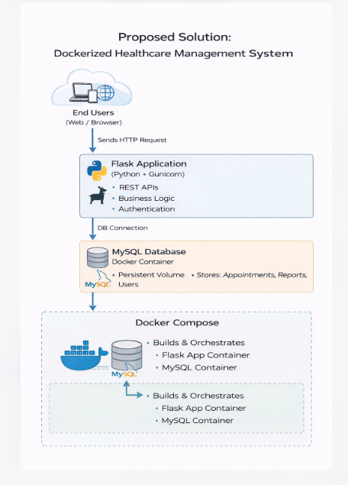

3.2 Overall Architecture / Workflow

  - Developer designs and implements the healthcare backend service using Python and the Flask framework.
  - The application structure is organized with source code, configuration files, and API routes.
  - All required libraries and dependencies are listed inside a requirements file to ensure consistent installation.
  - Environment variables are configured for database connection, secret keys, and runtime settings.
  - A multi-stage Dockerfile is created to build a clean and optimized container image while separating build-time and runtime dependencies.
  - During the build process, the application code and dependencies are packaged into a lightweight production-ready container.
  - A Docker Compose configuration file is prepared to define multiple services and their relationships.
  - Docker Compose starts the Flask application container.
  - Docker Compose also launches the database container required for storing healthcare data.
  - Persistent storage volumes are attached so database data remains safe even if containers restart.
  - Containers automatically join a shared internal network for secure communication.
  - The application container connects to the database container using the service name instead of a manual IP address.
  - Required application ports are mapped from the container to the host machine.
  - Once containers start successfully, the healthcare service initializes and verifies database connectivity.
  - API endpoints become active and ready to process requests.
  - Users or testers access the service via browser, localhost URL, or API testing tools.
  - Container logs provide real-time status updates for debugging and monitoring.
  - If code changes are made, containers can be rebuilt quickly without reconfiguring the whole environment.

  - The same container setup can be deployed on another system, server, or cloud platform with identical behavior.
  - This workflow ensures consistent development, testing, and deployment with minimal manual setup using container tools like Docker.
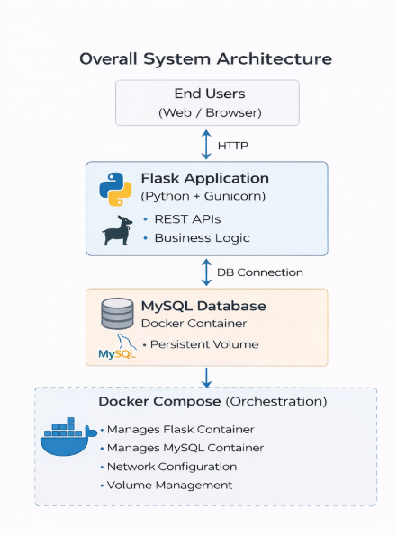

Step-by-step Workflow
- User (Patient)
  - Patient accesses the system via web browser.
- Register / Login
  - User creates an account or logs in.
- Book Appointment
  - Patient selects doctor/date and books appointment.
- System Stores Data in MySQL
  - Appointment details are saved in database.
- Doctor Reviews Appointment
  - Doctor logs in and checks patient details.
- Doctor Updates Report / Scan Details
  - Doctor enters diagnosis, prescriptions, scan results.
- Report Stored in Database
  - Final medical report is saved.
  - Patient can later view/download it.
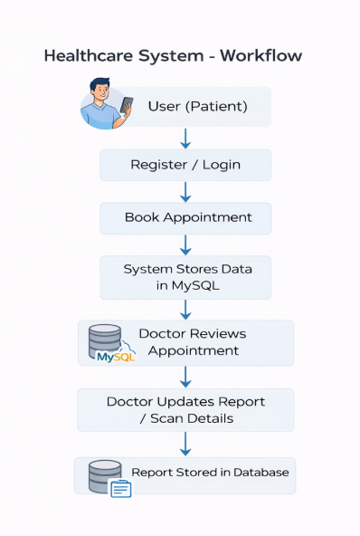

3.3 Tools & Technologies Used

- Python – Main programming language used to develop the healthcare backend service.
- Flask – Lightweight Python web framework used to build REST APIs and handle routing, requests, and responses.
- Docker – Containerization platform from Docker used to package the application with all dependencies into portable containers.
- Docker Compose – Tool used to define and run multi-container applications (application + database) with a single configuration file.
- Git – Version control system used for tracking code changes and managing project history.
- GitHub – Repository hosting platform from GitHub used for source code management, collaboration, and remote backups.
- CI/CD using Jenkins – Automation server from Jenkins used to automate build, testing, and deployment pipelines.

Additional Technologies

- PostgreSQL / MySQL / SQLite – Database systems used for storing healthcare-related records such as patient data and appointments.
- REST API Architecture – Used for communication between frontend/client and backend service.
- JSON – Data format used for sending and receiving API responses.

- Environment Variables (.env)– Used for secure configuration of credentials and runtime settings.
- VS Code – Code editor from Microsoft used for writing and managing the project.
- Postman – API testing tool from Postman used to test healthcare endpoints.
- Linux-based Docker Images – Used as the base runtime environment for lightweight container execution.
- Virtual Environment (venv) – Used in development for isolated Python dependency management.
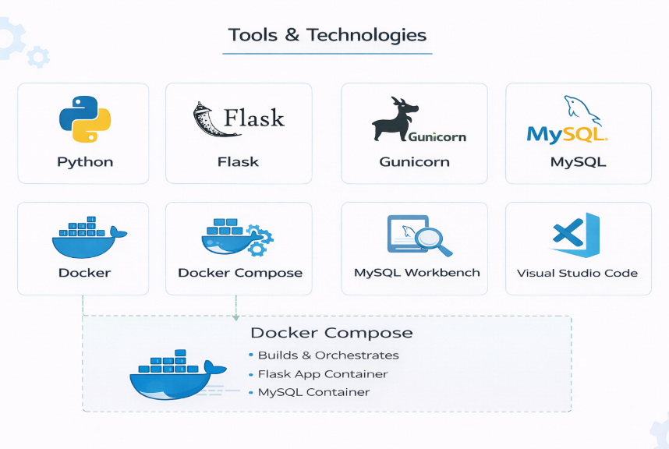

4. Results & Output

4.1 Screenshots / outputs
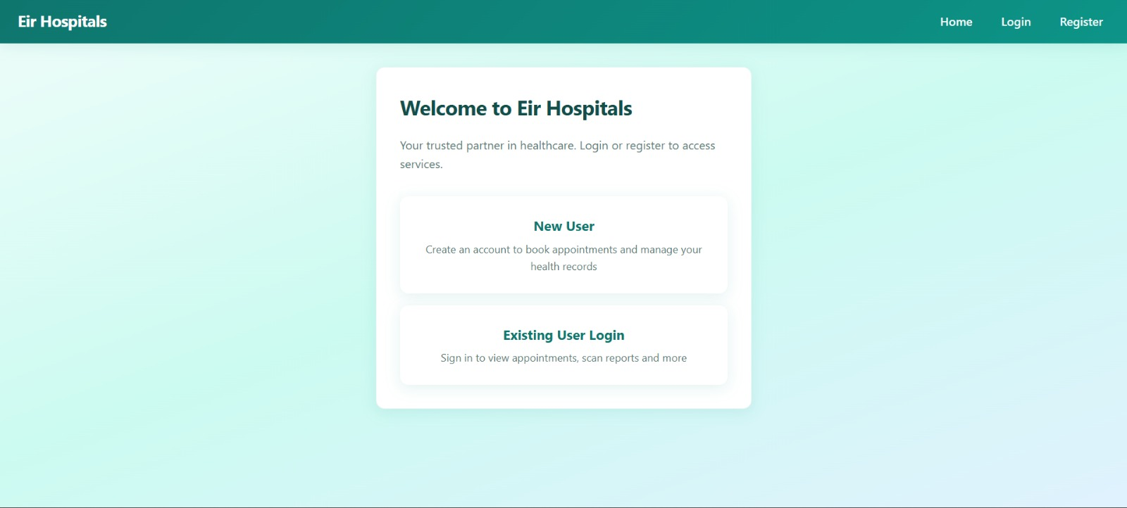

Application Home Page Screenshot

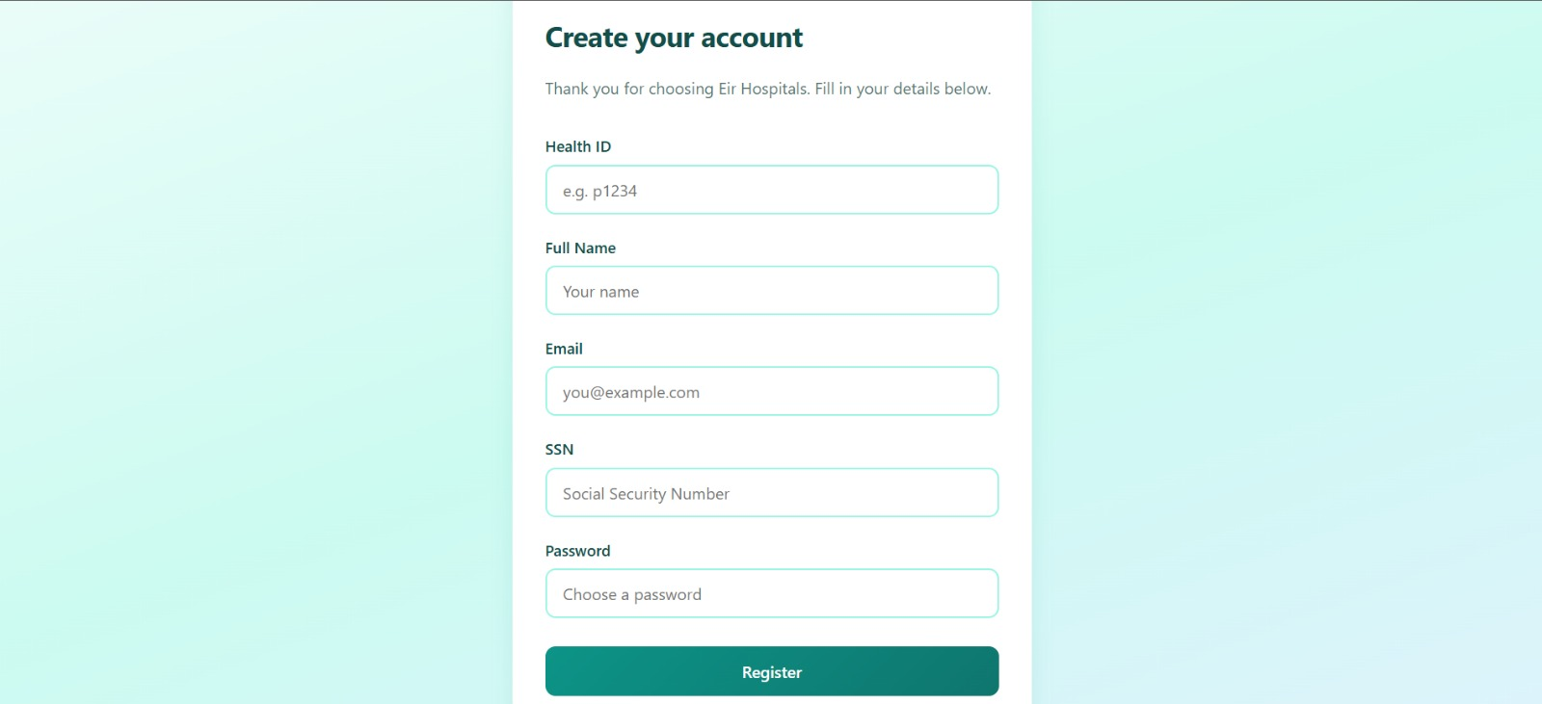

Application Account Creation Page Screenshot

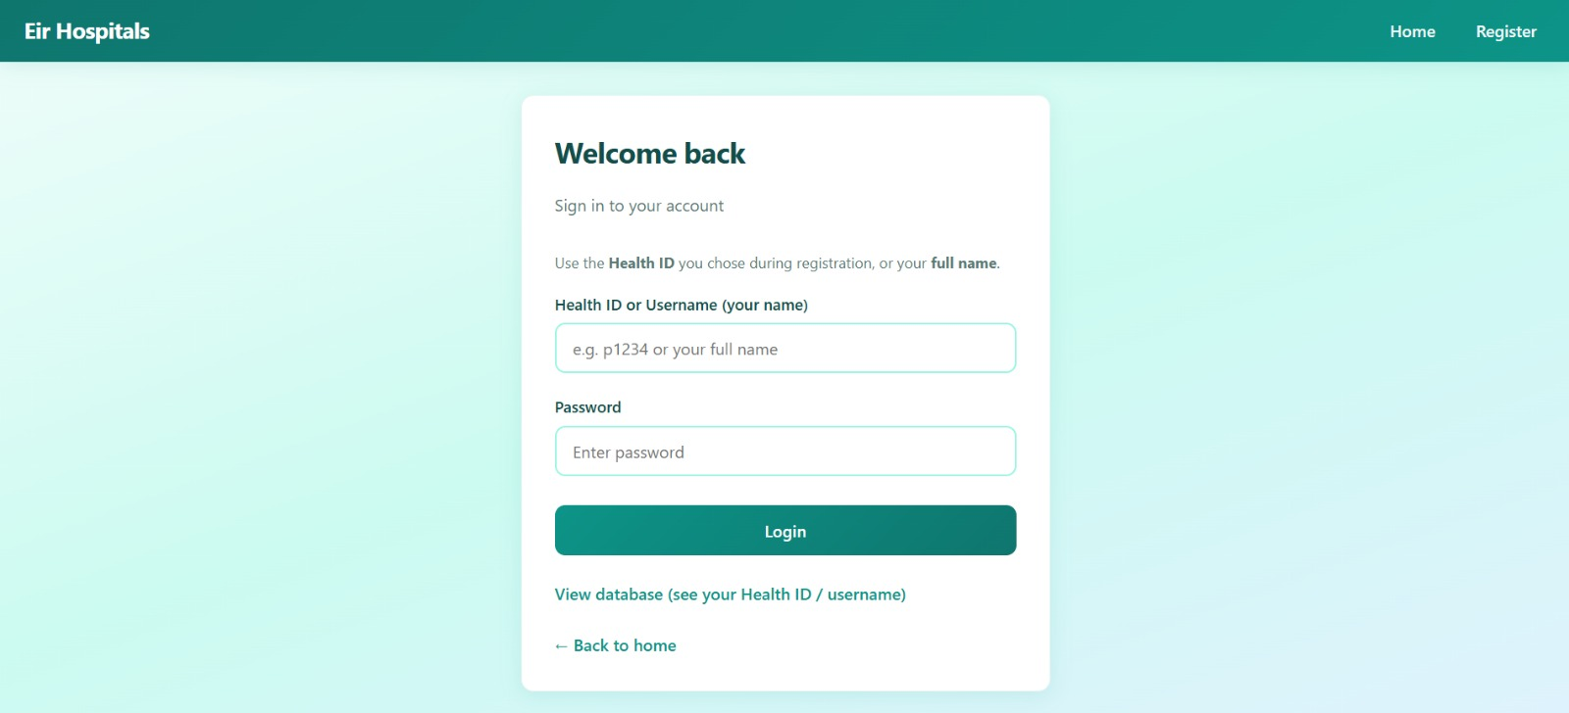

Application Login Page Screenshot

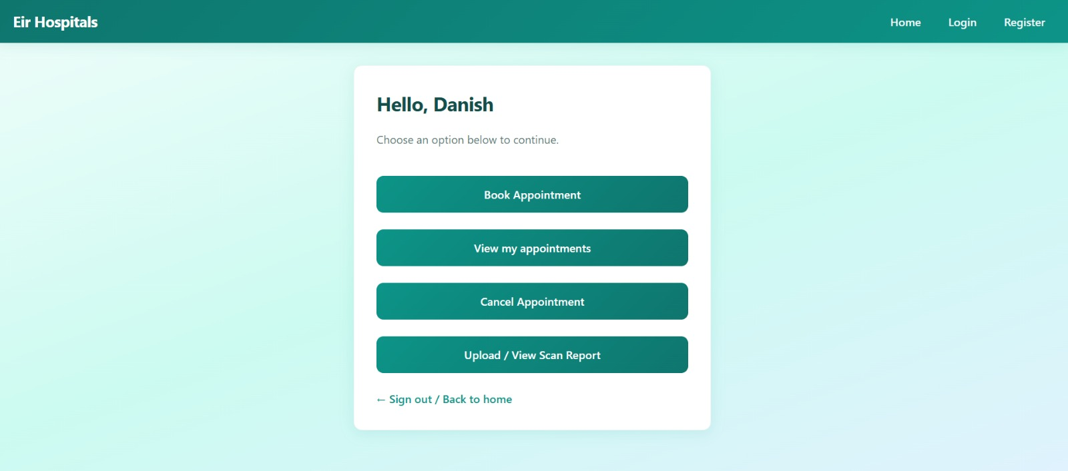

Application Feature Page Screenshot

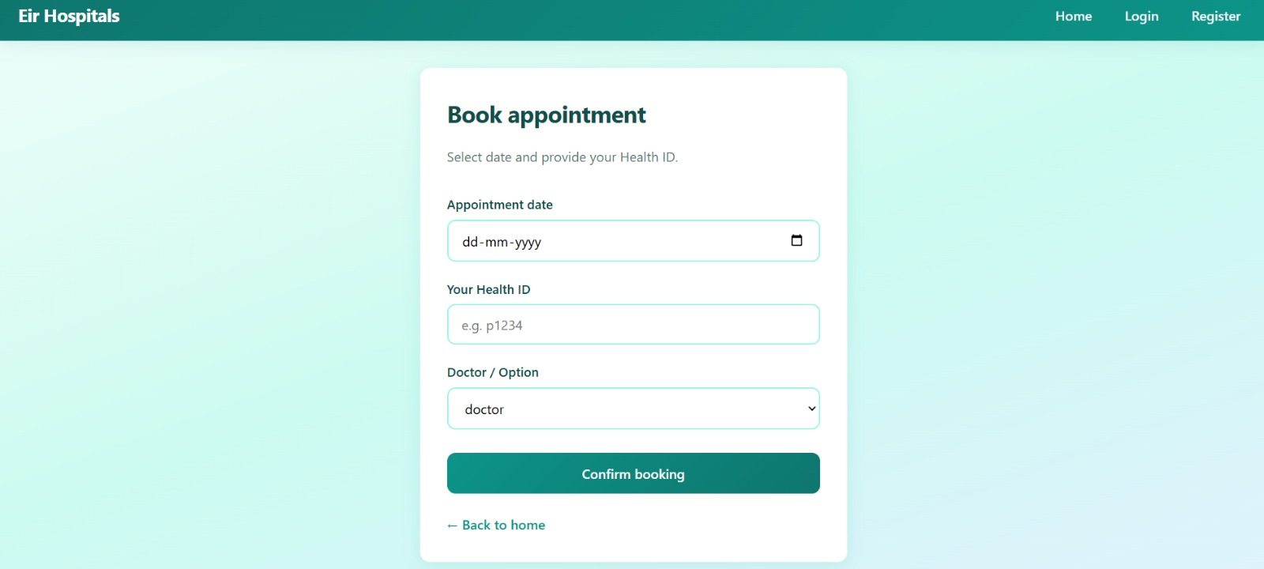

Application Appointment Booking Screenshot

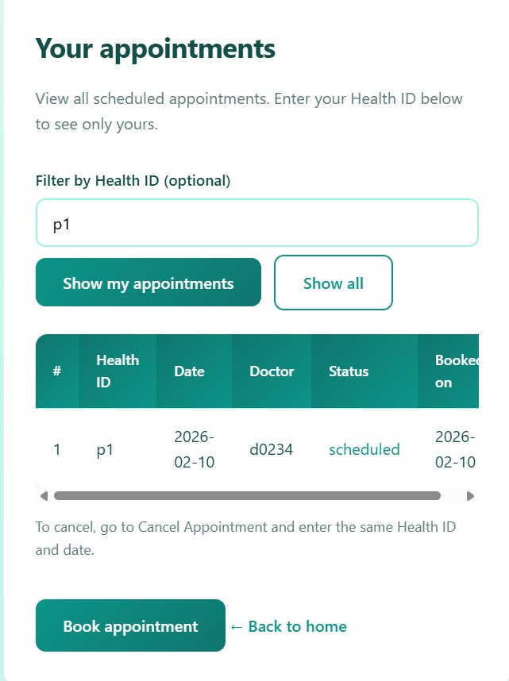

Application Appointment History Screenshot

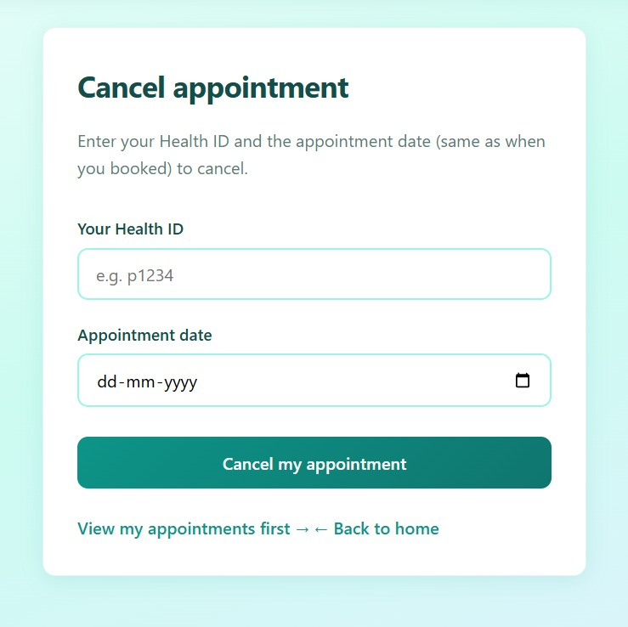

Application Appointment Booking Cancelation Screenshot

4.2 Reports / dashboards / models

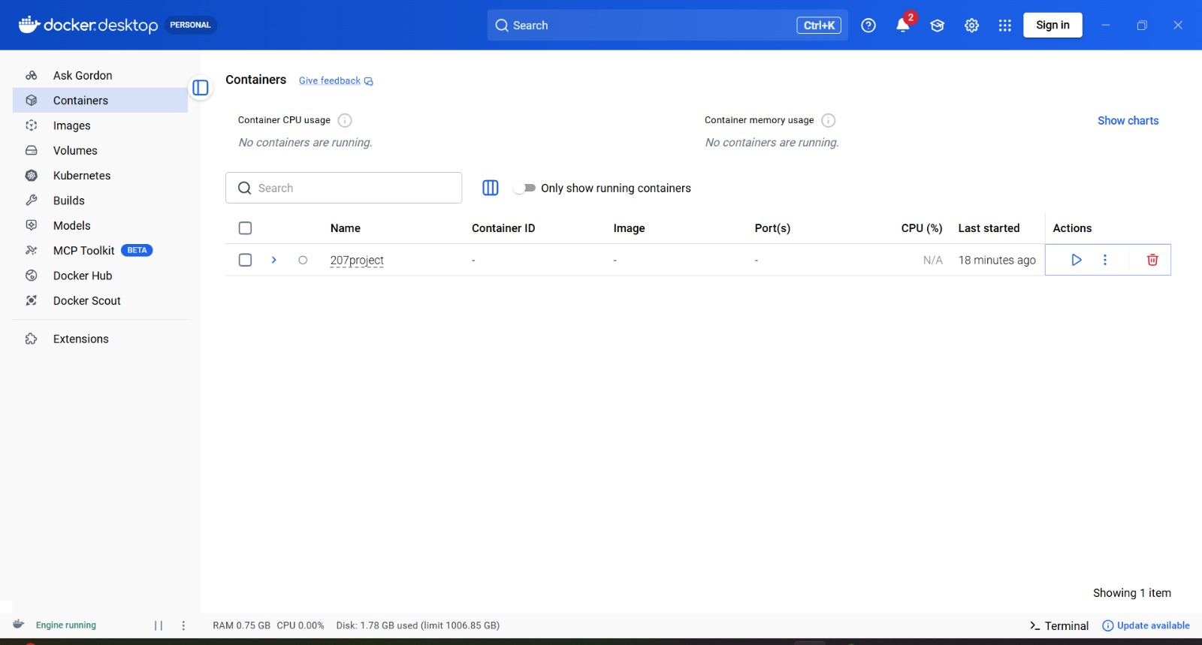

Application Docker Container Screenshot

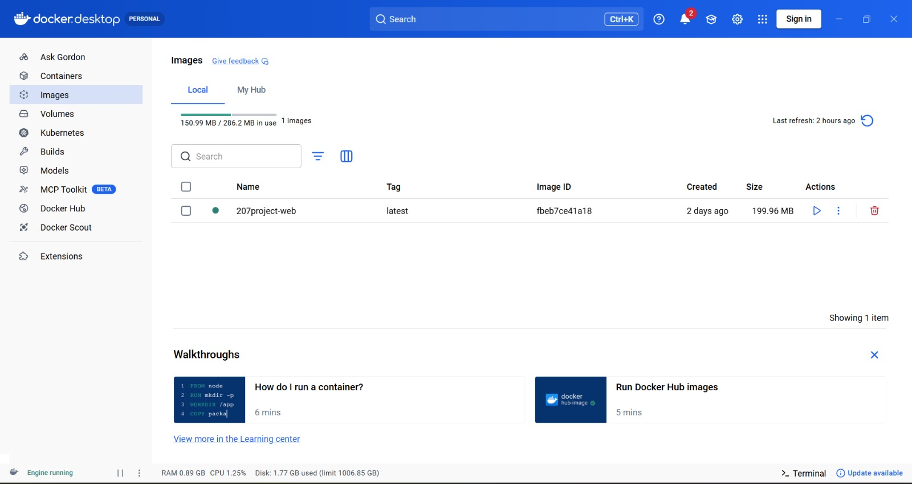

Application Docker Image Screenshot

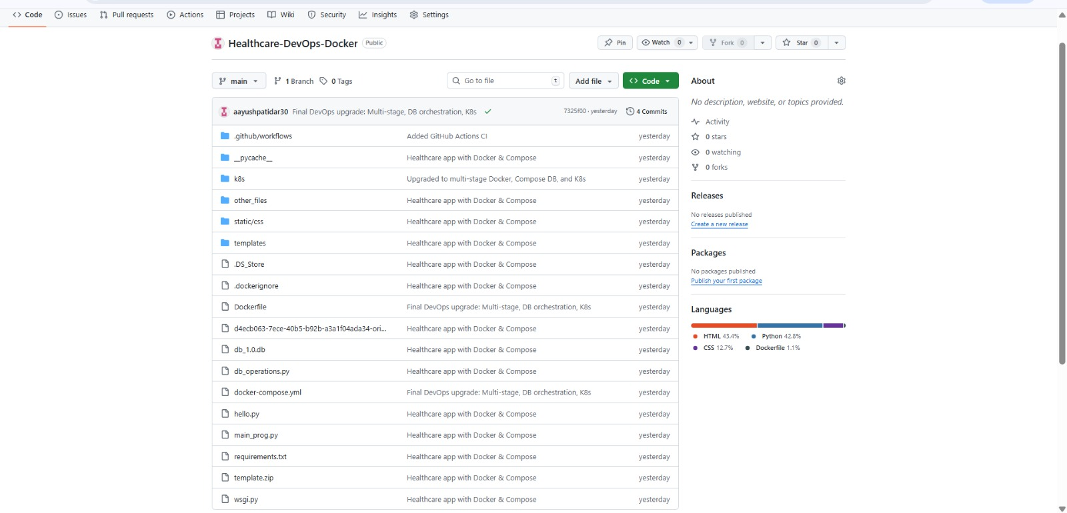

Application Git Repository Screenshot

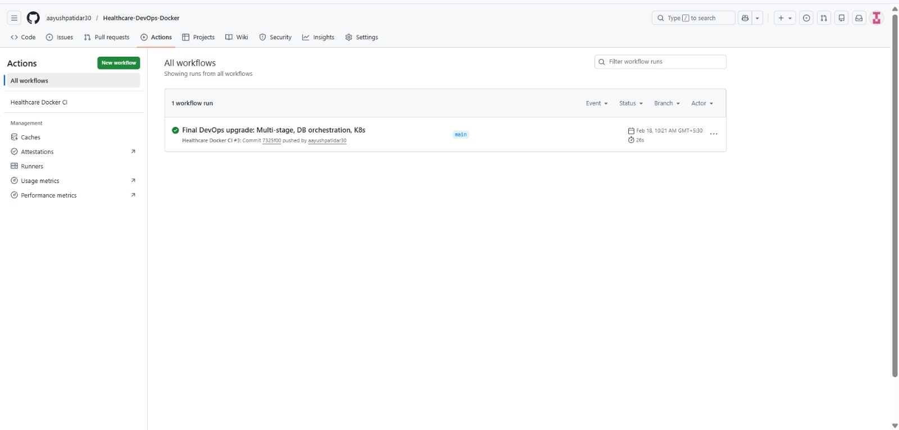

4.3 Key outcomes

- Successfully deployed the healthcare service inside containerized environments using Docker.
- Reduced environment setup time significantly by eliminating manual dependency installation.
- Achieved consistent application deployment across multiple systems without configuration conflicts.
- Improved application portability so the system can run on developer machines, servers, or cloud platforms.
- Enhanced security by isolating the application and its dependencies inside controlled containers.
- Simplified the overall deployment workflow with a single command to start all services.
- Enabled smooth integration between the application container and database container.
- Reduced chances of runtime errors caused by missing libraries or incompatible versions.
- Improved collaboration among team members by ensuring identical working environments.
- Faster onboarding of new developers since no complex setup process is required.
- Achieved structured and organized project architecture suitable for real-world deployment.
- Provided reliable container logs and runtime feedback for debugging and monitoring.
- Supported quick rebuilding and redeployment whenever application updates are made.
- Demonstrated readiness for CI/CD automation using platforms like jenkins.
- Prepared the project for future scaling and migration to cloud container platforms.
- Reduced system dependency on host operating system configuration.
- Increased development productivity due to reproducible environments.
- Established a strong foundation for modern DevOps-based healthcare service deployment.

5. Conclusion
The Dockerized Healthcare Service project successfully demonstrated how a healthcare backend application developed using Python and the Flask framework can be efficiently containerized to achieve reliable, secure, and portable deployment. One of the primary achievements of this project was eliminating common software deployment challenges such as dependency conflicts, inconsistent runtime environments, and complex manual setup procedures. By packaging the complete application along with its libraries, runtime configuration, and system requirements into containers using Docker, the system ensured that the healthcare service runs identically across development, testing, and production platforms.
The project also implemented multi-stage container builds to create optimized and lightweight production images. This approach reduced unnecessary files and improved security while maintaining application performance. Through the use of container orchestration with Docker Compose, both the application service and its database were configured to run together in a coordinated environment. This allowed seamless communication between services, simplified startup procedures, and provided a structured deployment workflow that mirrors real-world industry practices.
Another significant contribution of the project was simplifying collaboration among development team members. By maintaining the complete deployment configuration inside the project repository hosted on GitHub, any developer can clone the project and run the healthcare system with minimal setup effort. This reproducible environment greatly reduces onboarding time, prevents configuration-related bugs, and supports efficient teamwork. The automated container startup process also minimizes human error and ensures consistent behaviour regardless of the underlying operating system or machine configuration.
From a learning perspective, this project provided valuable practical exposure to modern DevOps methodologies, container lifecycle management, service networking, dependency isolation, and deployment automation techniques. It strengthened understanding of how real production systems are packaged, distributed, and maintained in professional software environments. The implementation also prepared the application for future scalability, cloud deployment, and continuous integration pipelines, making it suitable for enterprise-level healthcare system expansion.
Overall, the Dockerized Healthcare Service project successfully achieved its objective of creating a standardized, portable, and efficient deployment solution for a healthcare web service. It not only improved system reliability and security but also demonstrated how containerization technologies can streamline software delivery, enhance maintainability, and support modern industry deployment standards while providing strong foundational experience in full-stack backend deployment and DevOps practices.

6. Future Scope & Enhancements

The current Dockerized Healthcare Service provides a strong foundation for portable and consistent deployment of the backend application. However, the system can be further enhanced and expanded in several ways to make it suitable for large-scale production use, enterprise healthcare environments, and advanced DevOps workflows.
One of the major future improvements is deploying the containerized application on a container orchestration platform such as Kubernetes. While Docker Compose is suitable for development and small deployments, Kubernetes enables automated scaling, load balancing, rolling updates, self-healing containers, and high availability. By migrating the healthcare service to a Kubernetes cluster, the system would be capable of handling thousands of concurrent users while maintaining uptime and performance reliability.
Another important enhancement is implementing a fully automated CI/CD pipeline using automation servers such as Jenkins or built-in workflows from GitHub. Continuous Integration would automatically test the healthcare service whenever new code is pushed, while Continuous Deployment would build the Docker image and deploy updated containers automatically. This would significantly reduce manual deployment effort, shorten release cycles, and improve software quality by ensuring every update passes automated checks before production release.
Security can also be strengthened by introducing a complete authentication and authorization mechanism within the healthcare system. Future versions may include secure login systems, encrypted password storage, multi-factor authentication, and role-based access control for different types of users such as administrators, doctors, staff members, and patients. This would ensure that sensitive healthcare data remains protected and accessible only to authorized users, meeting real-world compliance requirements.
Monitoring and observability features represent another valuable future direction. Integration with container monitoring and logging platforms would allow real-time tracking of system performance, container health, API response times, and resource utilization. Alerts could be generated automatically if any container fails or if system performance drops below acceptable levels. Such monitoring capabilities would help administrators quickly detect and resolve issues, ensuring continuous service availability.
The project can also be expanded by deploying the healthcare containers on major cloud platforms such as Amazon Web Services or Microsoft Azure. Cloud deployment would provide scalable infrastructure, managed database services, automated backups, global accessibility, and improved disaster recovery capabilities. Using cloud container services would also eliminate the need for maintaining local servers and would support automatic scaling based on user demand.
Beyond deployment improvements, the healthcare system itself can be functionally enhanced by adding advanced modules such as patient history analytics, automated appointment reminders, digital prescription management, report generation dashboards, telemedicine integration, and secure API access for third-party healthcare services. Integration with mobile applications could also be considered to allow patients and doctors to interact with the system remotely.
In conclusion, while the current implementation successfully demonstrates containerized healthcare service deployment, future enhancements involving orchestration, automation, security, monitoring, and cloud scalability can transform the project into a fully production-ready healthcare platform aligned with modern enterprise DevOps and cloud-native architecture standards.

